**Automatic Detection of Cataract (Isma)**

**Introduction**

**Cataract**

Cataract is one of main cause of blindness. It is the clouding of the clear lens. It has been reported that 47.8 % of global blindness is due to cataracts. One of the major causes is age. It is due to the opacity or darkness of crystalline lens. Cataract eye disorder can be detected by looking at the lens of the human eye. The anatomical changes occurred in lens due to abnormality which can be used in automatic detection of cataract.

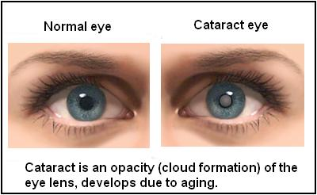

**Causes**

Cataracts occur when there is a buildup of protein in the lens that makes it cloudy. This prevents light from passing clearly through the lens, causing some loss of vision. Since new lens cells form on the outside of the lens, all the older cells are compacted into the center of the lens resulting in the cataract.

**Major Causes of Cataract include:**

* Advancing Age
* Ultraviolet radiation from sunlight and other sources.
* Diabetes.
* Hypertension.
* Obesity.
* Smoking.
* Prolonged use of corticosteroid medications

**Signs And Symptoms**

* Clouded, blurred or dim vision.
* Increasing difficulty with vision at night.
* Sensitivity to light and glare.
* Seeing "halos" around lights.
* Frequent changes in eyeglass or contact lens prescription.
* Fading or yellowing of colors.
* Double vision in a single eye.

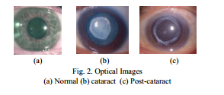

**Types of Cataract (Classes of Cataract)**

There are three types of cataract:

**Nuclear Cataract** (graded using Slit-lamp images): A **nuclear cataract** forms deep in the central zone (nucleus) of the lens. Nuclear cataracts usually are associated with aging.

**Cortical Cataract** (graded using retro illumination images): A **cortical cataract** is characterized by white, wedge-like opacities that start in the periphery of the lens and work their way to the center in a spoke-like fashion. This type of cataract occurs in the lens cortex, which is the part of the lens that surrounds the central nucleus.

**Posterior Sub capsular Cataracts** (graded using retro illumination images:A **subcapsular cataract** occurs at the back of the lens. People with diabetes or those taking high doses of steroid medications have a greater risk of developing a subcapsular cataract.

**Proposed Automated System for Cataract Detection**

Image of eye

F Feature Extraction

F Classifier

Normal Image

Cataract Image

**Techniques And Methods Used to Detect Cataract:**

* **Small Ring Area**

(In cataract images the color of the inner surface of cornea is more whitish as compared to normal images).

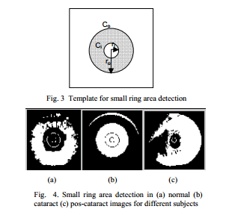

* **Big Ring Area**

(In Cataract images the outer surface of the cornea s more bright as compared to normal images).

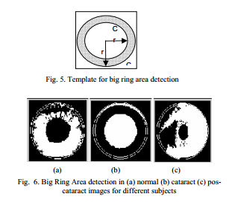

* **Edge pixel count**

(Using Edge Detection Image Processing technique e.g.Sobel or canny)

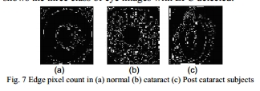

* **Object Perimeter**

(Morphological Image Processing Operation i.e. erosion is used to extract Object Perimeter)

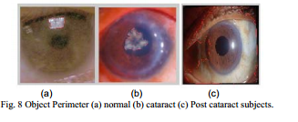

**Note:** Other intensity based and texture based features can also be used for cataract detection. For example

Global Thresholding

Average Intensity etc.

**Detection of Cataract**

The anatomical changes occurred in the lens due to the abnormality is one of the decision factors for the detection of cataract.

**Classification of Optical Eye Image as Normal or Cataract**

Using the extracted features , image can be classified as normal and cataract by applying any classifier e.g. SVM, Neural Networks, KNN, K-means.